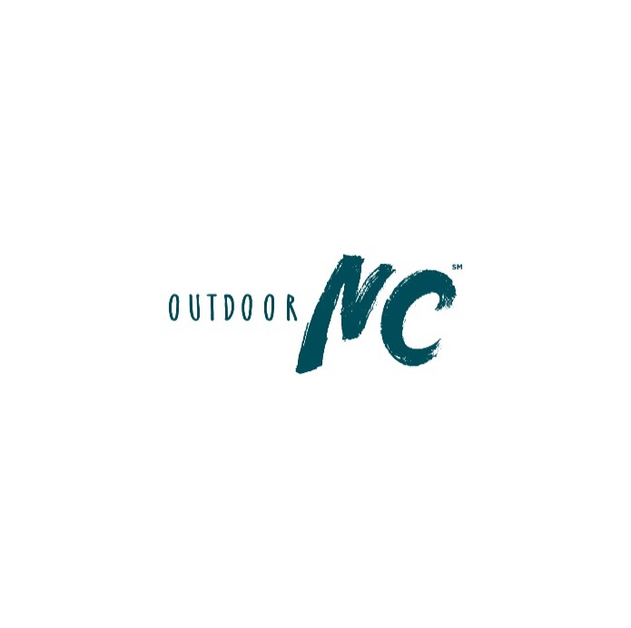

Have fun and add these Outdoor NC stickers to your Instagram stories.

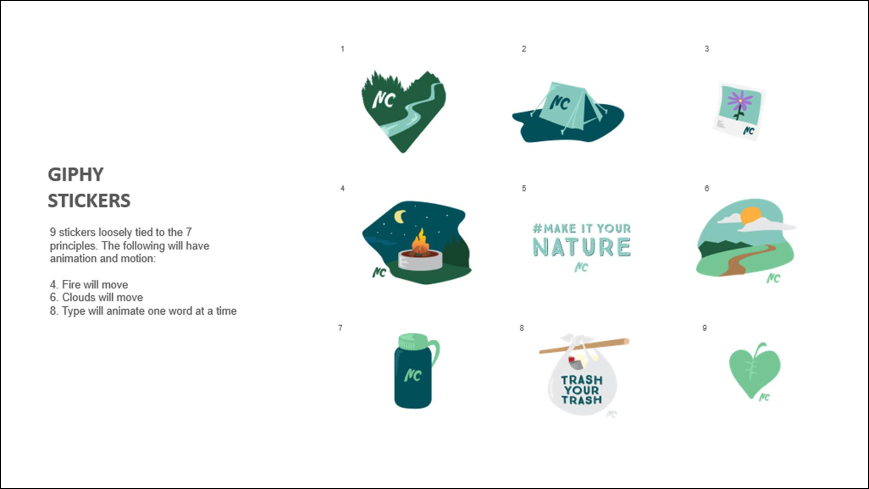

How to add:

1. When creating an Instagram Story, click to add GIF.

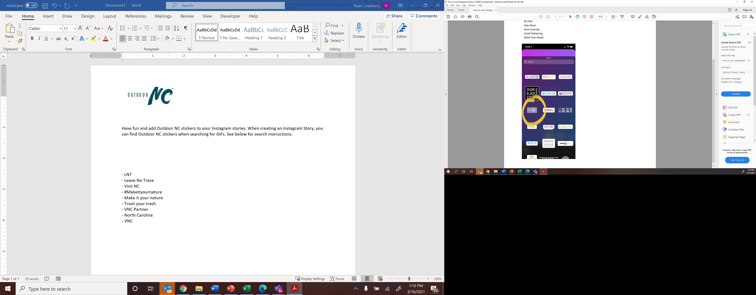

1. Use the following search terms to find GIFs related to Outdoor NC:

*- LNT*

*- Leave No Trace*

*- Visit NC*

*- #Makeityournature*

*- Make it your nature*

*- Trash your trash*

*- VNC Partner*

*- North Carolina*

*- VNC*