Blue Ridge Parkway News Release

Blue Ridge Parkway
199 Hemphill Knob Road
Asheville, NC 28803

828-271-4779 phone
www.nps.gov/blri/
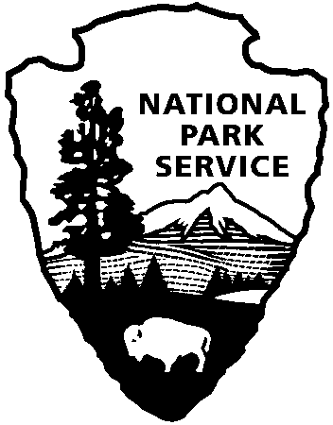
National Park Service
U.S. Department of the Interior

Release Date: October 24, 2011
Contact: Phil Francis, (828) 348-3405; email, phil_francis@nps.gov

Parkway Announces New General Management Plan and Public Review Period

ASHEVILLE - The National Park Service (NPS) announces the draft Environmental Impact Statement (Draft EIS) for the Blue Ridge Parkway’s General Management Plan (GMP) is available for public comment. The full document is available for review at www.parkplanning.nps.gov/blri. The NPS has invited all interested parties to attend any of four open house style public meetings as follows to learn about the plan and to submit comments:

Date: Wednesday, November 2, 2011
Time: 3:00 p.m. to 7:00 p.m.
Location: Folk Art Center
Milepost 382 Blue Ridge Parkway, Asheville NC

Date: Thursday, November 3, 2011
Time: 3:00 p.m. to 7:00 p.m.
Location: Blowing Rock Art and History Museum
159 Chestnut Street, Blowing Rock, NC

Date: Wednesday, November 9, 2011
Time: 3:00 p.m. to 7:00 p.m.
Location: Nelson Memorial Library
8521 Thomas Nelson Highway, Lovingston, VA

Date: Thursday, November 10, 2011
Time: 3:00 p.m. to 7:00 p.m.
Location: Brambleton Center
3738 Brambleton Avenue, Roanoke, VA

Each meeting will feature exhibits that facilitate understanding of the plan. This plan provides comprehensive guidance for perpetuating natural systems, preserving cultural resources, and providing opportunities for quality visitor experiences along the parkway for the next 20+ years.

The draft plan evaluates a range of alternatives to compare the advantages of one course of action to another. The planning team developed two “action” alternatives (B and C). The third alternative (A) is the “no-action” alternative that describes how the parkway is currently managed, providing a basis for comparing the other alternatives. The comments and suggestions that many of you provided earlier were considered when developing the action alternatives presented in the plan.

Alternative B has been identified as the National Park Service’s preferred management approach. The preferred alternative emphasizes the original parkway design and traditional driving experience, while enhancing outdoor recreational opportunities and regional natural resource connectivity, and providing modest improvements to visitor services. Parkway Superintendent Phil Francis states, “This is the Parkway’s first General Management Plan and it provides for the management of the resource to insure the quintessential parkway experience is available to future generations.”
In essence, the preferred alternative proposes modest re-investment in the parkway's aging infrastructure, update inadequate visitor services and facilities, and protect a biologically diverse natural environment that is only surpassed by two other units in the national park system. This reinvestment echoes the original thinking of the parkway founders during the Great Depression—to invest in building the parkway to create a catalyst for long-term, regional economic vitality.

Comments are also welcome through December 16, 2011 using one of the following methods:

Submit comments on the NPS planning website: www.parkplanning.nps.gov/blri.

Submit written comments by mail to: Superintendent Philip A. Francis, Jr.
Blue Ridge Parkway
199 Hemphill Knob Road, Asheville, NC 28803

www.nps.gov

About the National Park Service. More than 20,000 National Park Service employees care for America’s 395 national parks and work with communities across the nation to help preserve local history and create close-to-home recreational opportunities. Learn more at www.nps.gov.

